SYNOPSIS

**A PROJECT REPORT**

**(Industrial/Software)**

**ON**

**WEB APPLICATION**

**(E.com-Store)**

SUBMITTED IN PARTIAL FULFILLMENT OF THE REQUIREMENTS FOR THE AWARD OF

THE DEGREE OF

**B. TECH IN COMPUTER SCIENCE & ENGINEERING**



**Sri Sukhmani Institute of Engineering & Technology**

**SUBMITTED BY: - SIGNATURE OF STUDENT: -**

**LOVKUSH _______________________**

**CANDIDATE’S DECLARATION**

I hereby certify that the project entitled (E-COM STORE Website) Online submitted by Lovkush in partial fulfilment of the requirement for the award of degree of the B.Tech at Sri Sukhmani Institute Of Engg. & Tech. is an authentic record of my own work carried out during a period from **Nov 2022 to MAY 2023**. The matter presented in this project has not formed the basis for the award of any other degree, diploma, fellowship, or any other similar titles.

Signature of the Student Place: Date:

**ACKNOWLEDGEMENT**

The success and outcome of this project require a lot of guidance and assistance from many people and we extremely privileged to have got this all along the completion of project. All that we have done is only due to such supervision and assistance and we would not forget to thank them.

We express our deep sense of gratitude to our respected Co-ordinator Ms Poonam, for their valuable help and guidance. We are also thankful to all the other faculty & staff members of company for their kind co-operation and help.

Finally, we would like to say that we are indebted to our parents for everything that they have done for us.

And we also thanks to God for being kind to us and driving us through this journey.

THANKS AGAIN TO ALL WHO HELPED US.

Signature of Student

Lovkush

Date: - 08-05-2023

**ABSTRACT**

E-Commerce web application, Cooperative Store Management System is the platform where customers can shop online without having to visit the store physically. It aimed at reducing the workload of the salesperson and minimize the manual errors by automating the record entry. Customers can hugely minimize the cost incurred and time being wasted using a system. Moreover, customers can get better services and the shopping can be done at one’s convenience as the services can be availed from their home. This will not only help to attract new customers but also retain regular customers which ultimately helps the business to grow in a long run. Interview, brainstorming, and team meeting were done to get the complete requirement of data for a system. Frontend interface can be used by the customers to view the items and place order as per their needs. The paper is going to provide the information of the processes involved during the development of the application. It will also present the design process, methodology and overall working of the system.

**ABOUT COMPANY**



Excellence technology provides best software industrial training in Chandigarh which helps you to reboot your professional career to excellent point to achieve your goal. Get an All types of software testing training which helps you to increase your testing software ability with knowledgeable and experienced faculty members, a transparent teaching methodology is applied. The advanced training is few of the things that make Excellence Technology a best Industrial institute in Chandigarh. We Are Providing Digital Marketing Services to Local & Global Clients. Our Main Services Are Website Designing & Development, Search Engine Optimization (SEO), Search Engine Marketing (SMM Or PPC), Lead Generation, Online Branding Etc. Our aim is to provide the best learning environment to our students. We help them to discover their potential to build their professional career. We believe that our students should receive best training. so that this led to effective careers growth and development**.**

**TABLE OF CONTENTS**

|  |  |  |  |  |
| --- | --- | --- | --- | --- |
| ***TITLE*** | | | | ***Page no*** |
| *Candidate Declaration* | | | | *i* |
| *Acknowledgement* | | | | *ii* |
| *Abstract* | | | | *iii* |
| *About Company* | | | | *iv* |
| *Table Of Contents* | | | | *v* |
| **Chapter 1:** | | | **INTRODUCTION** | **6-14** |
|  | 1.1 | | Module Description Of HTML | 6 |
|  | 1.2 | | Technology Used | 8 |
|  | | 1.2.1 | Front End Technologies | 9-14 |
| **Chapter 2:** | | | **Project Work** | **15-24** |
|  | 2.1 | | Project work.. | 15-19 |
|  | 2.2 | | E-Com | 20-24 |
| **Chapter 3:** | | | **Objectives** | **25-26** |
|  | 3.1 | | Project Dashboard | 25 |
|  | 3.2 | | Selling product online | 26 |
| **Chapter 4:** | | | **Planning & Methodology** | **27-29** |
|  | 4.1 | | Methodology | 27-28 |
|  | 4.2 | | Data Flow Diagram | 29 |
| **Chapter 5:** | | | **Conclusion and Future Scope** | 30 |
| **Chapter 6:** | | | **System Requirement & Specification** | 31 |
| **References** | | | | 31 |

# CHAPTER 1

## 1.1 INTRODUCTION OF THE PROJECT

**A Ecommerce website is designed to manage all the functionalities of e-commerce store.**

In this project user add own product to sell it with unique id of products and user. Users can also Add, Update , Delete and see the all product details in the website. This complete project is based on MERN stack technology.

*With the MERN Stack, a JavaScript Stack, full-stack online applications can be deployed rapidly and easily. MongoDB, Express, React, and Node.js are all part of the MERN Stack. It was created to speed up and improve the development process.*

*All these four powerful techniques provide an end-to-end architecture for creating MERN stack open-source projects such as online apps.*

1. M for MongoDB

In MERN, the “M” refers to Mango DB, which is the database tier for a MERN application. MongoDB is a document-oriented No-SQL database used to hold back-end applications.

Objects —> Collection —> Documents —> Data

1. E for Express JS

Express is a layered framework; the responsibility of this is to take care of the structure and functionality of the back end and topped on Node.js, which makes Node-based Web app development much faster.

1. R for React: Front End Library

React facilities the creation of a user interface on a single-page web application and was developed and distributed by Facebook as an open-source library.

1. N for Node.js: JS Runtime Environment

Node.js is a back-end JavaScript execution framework that works across several platforms and is open source. The V8 engines that power Node.js are responsible for running JS code

### 1.2WORKING OF PROJECT

Admin can add, edit, delete and update the product details on website. The whole system is divided into sub-systems, each of which deals with one or more external agents and which together provide all of functionality of the e-commerce system as a whole.

Each user has been give a Username and Password for security reason and using there account there account customer login in website.

**1.2.1 Front-End:-**

▶ **What is HTML?**

HTML is an acronym which stands for Hyper Text Markup Language which is used for creating web pages and web applications. Let's see what is meant by Hypertext Markup Language, and Web page.

Hyper Text: HyperText simply means "Text within Text." A text has a link within it, is a hypertext. Whenever you click on a link which brings you to a new webpage, you have clicked on a hypertext. HyperText is a way to link two or more web pages (HTML documents) with each other.

Markup language: A markup language is a computer language that is used to apply layout and formatting conventions to a text document. Markup language makes text more interactive and dynamic. It can turn text into images, tables, links, etc.

Web Page: A web page is a document which is commonly written in HTML and translated by a web browser. A web page can be identified by entering an URL. A Web page can be of the static or dynamic type.

**Purpose of this Figure:**

In this figure we creating the folder by using command prompt of app, where the app will work in the Visual Studio.

**Purpose of this Figure:**

In this Figure the file we will create by command prompt they were accessed by Visual Studio to make a app for the project.

**Purpose of this Figure:**

In this Figure the HTML is vary to the Visual Code to understand the whole program of the App which we start the website of Phonomania.

**Features of HTML :-**

* **Open source:**

Easily available on internet so can be downloaded.

* **Error – Reporting:**

Whenever an error occurs in any statement, it is reported at the same moment. And

can be corrected at the same moment.

* **Simple:**

Syntax is easy to remember, learn and understand.

* **Platform – Independent:**

It can run on any operating system without any change in syntax. LAMP for Linux operating system, WAMP for windows operating system, XAMPP for both windows and Linux operating system.

* **Interpreted:**

This language is already interpreted. It doesn’t take any extra time for compilation or interpretation.

▶ **CSS :-**

**C**ascading **S**tyle **S**heets, fondly referred to as CSS, is a simple design language intended to simplify the process of making web pages presentable.

CSS handles the look and feel part of a web page. Using CSS, you can control the color of the text, the style of fonts, the spacing between paragraphs, how columns are sized and laid out, what background images or colors are used, layout designs,variations in display for different devices and screen sizes as well as a variety of other effects.

CSS is easy to learn and understand but it provides powerful control over the presentation of an HTML document. Most commonly, CSS is combined with the markup languages HTML or XHTML.

Cascading Style Sheets level 1 (CSS1) came out of W3C as a recommendation in December 1996. This version describes the CSS language as well as a simple visual formatting model for all the HTML tags. CSS2 became a W3C recommendation in May 1998 and builds on CSS1. This version adds support for media-specific style sheets e.g. printers and aural devices, downloadable fonts, element positioning and tables.

**Advantages of CSS**

* CSS saves time
* Pages load faster
* Easy maintenance
* Superior styles to HTML
* Multiple Device Compatibility
* Global web standards

**Purpose of this Figure:**

In this Figure we use cd front-end to configure our app folder is on right location or not so we check it by usingmcd command in Terminal.

React:-



React is a [JavaScript](https://www.simplilearn.com/tutorials/javascript-tutorial/introduction-to-javascript)-based UI development library. Facebook and an open-source developer community run it. Although React is a library rather than a language, it is widely used in web development. The library first appeared in May 2013 and is now one of the most commonly used frontend libraries for web development.

React offers various extensions for entire application architectural support, such as Flux and React Native, beyond mere UI.

## ReactJS History

When compared to other technologies on the market, React is a new technology. Jordan Walke, a software engineer at Facebook, founded the library in 2011, giving it life. The likes of XHP, a straightforward HTML component framework for PHP, have an influence on React. React's newsfeed was its debut application in 2011. Later, Instagram picks it up and incorporates it into their platform.



## React

React’s popularity today has eclipsed that of all other front-end development frameworks. Here is why:

* Easy creation of dynamic applications: React makes it easier to create dynamic web applications because it requires less coding and offers more functionality, as opposed to JavaScript, where coding often gets complex very quickly.
* Improved performance: React uses Virtual DOM, thereby creating web applications faster. Virtual DOM compares the components’ previous states and updates only the items in the Real DOM that were changed, instead of updating all of the components again, as conventional web applications do.
* Reusable components: Components are the building blocks of any React application, and a single app usually consists of multiple components. These components have their logic and controls, and they can be reused throughout the application, which in turn dramatically reduces the application’s development time.
* Unidirectional data flow: React follows a unidirectional data flow. This means that when designing a React app, developers often nest child components within parent components. Since the data flows in a single direction, it becomes easier to debug errors and know where a problem occurs in an application at the moment in question.
* Small learning curve: React is easy to learn, as it mostly combines [basic HTML](https://www.simplilearn.com/tutorials/html-tutorial/what-is-html) and JavaScript concepts with some beneficial additions. Still, as is the case with other tools and frameworks, you have to spend some time to get a proper understanding of React’s library.
* It can be used for the development of both web and mobile apps: We already know that React is used for the development of [web applications](https://www.simplilearn.com/progressive-web-apps-article), but that’s not all it can do. There is a framework called React Native, derived from React itself, that is hugely popular and is used for creating beautiful mobile applications. So, in reality, React can be used for making both web and mobile applications.
* Dedicated tools for easy debugging: Facebook has released a Chrome extension that can be used to debug React applications. This makes the process of debugging React web applications faster and easier.

## ReactJS Keys

After answering what is ReactJs, let us know what are keys.

While dealing with components that are produced periodically in React, keys are essential. Your component will continue to be uniquely identifiable after the modification if the key value is set.  They aid React in determining which elements have changed, been eliminated, or been added.

When making lists of components in React, you must use a special string personality factor "key". React uses keys to indicate which list items have been modified, destroyed, or altered. Or, to put it another way, we may say that keys are utilized to identify the components in lists.

# CHAPTER 2

**TECHNOLOGY & TOOLS**

**2.1 TECHNOLOGY USED**

## 2.2 HTML

HTML is a computer language devised to allow website creation. These websites can then be viewed by anyone else connected to the Internet. It is relatively **easy to learn**, with the basics being accessible to most people in one sitting; and quite **powerful** in what it allows you to create. It is constantly undergoing revision and evolution to meet the demands and requirements of the growing Internet audience under the direction of the organization charged with designing and maintaining the language.



HTML Logo

⮚ Hypertext is the method by which you move around on the web by clicking on special text called **hyperlinks** which bring you to the next page. The fact that it is *hyper* just means it is not linear i.e. you can go to any place on the Internet whenever you want by clicking on links there is no set order to do things in.

⮚ Markup is what **HTML tags** do to the text inside them. They mark it as a certain type of text (italicized text, for example).

⮚ HTML is a Language, as it has code-words and syntax like any other language.

CSS



Cascading Style Sheets (CSS) are a method of web design that formats web page content according to a presentation style specified by the web page author. There are several advantages to using CS to format the presentation elements of a web page. CSS essentially separates document content from the manner in which it is presented, thus allowing for more fluid transitions between various browser platforms. CSS also provides for more precise control for spacing, alignment, and positioning of content without relying on the need for layout tables or frames. Font style, color, and font size can all be manipulated using CSS as well.

#### BOOTSTRAP

Bootstrap is a free front-end framework for faster and easier web development. Bootstrap includes HTML and CSS based design templates for typography, forms, buttons, tables, navigation, modals, image carousels and many other, as well as optional JavaScript plugging. Bootstrap also gives you the ability to easily create responsive designs.



By using this framework we can easily manipulate the styling of any web page, like font style, text color, background color, flex, grid system, etc. Bootstrap Vesrion 4 & Vesrion 5 are the most popular versions. There are lots of other CSS frameworks like Tailwind CSS, Bulma, and Foundation but among them, this framework is the most popular because of below mentioned features:

It is Faster and Easier way for Web-Development.

It creates Platform-independent web-pages.

It creates Responsive Web-pages.

It designs responsive web pages for mobile devices too.

It is a free and open-source framework available on www.getbootstrap.com

##### JAVASCRIPT

JavaScript is a dynamic computer programming language. It is lightweight and most commonly used as a part of web pages, whose implementations allow client-side script to interact with the user and make dynamic pages. It is an interpreted programming language with object-oriented capabilities.

JavaScript is a lightweight, interpreted programming language. Designed for creating network-centric applications.

Complementary to and integrated with Java.

Complementary to and integrated with

HTML.



##### J-QUERY

j-Query is a fast and concise JavaScript Library created by John Resig in 2006 with a nice motto: **Write less, do more** j-Query tutorial for beginners and professionals provides deep knowledge of j-Query technology. Our j-Query tutorial will help you to learn j-Query fundamentals, example, selectors, events, effects, traversing, CSS and attributes.

J-Query is a small and lightweight JavaScript library. J-Query is cross-platform.

J-Query means "write less do more".

##### React.js



React.js, more commonly known as React, is a free, open-source JavaScript library. It works best to build user interfaces by combining sections of code (components) into full websites. Originally built by Facebook, Meta and the open-source community now maintain it. One of the good things about React is that you can use it as much or as little as you want! For example, you can build your entire site in React or just use one single React component on one page.

React.js is built using JSX – A combination of JavaScript and XML. Elements are created using JSX, then use JavaScript to render them on your site. While React has a steep learning curve for a junior developer, it’s quickly shaping into one of the most popular and indemand JavaScript libraries.

React is considered a JavaScript library rather than a framework, whereas the other options we’ll consider today are considered frameworks. It helps to think of a library as a tool that developers could use in any project and a framework as a whole design.

**ReactJS Advantages**

1. React.js builds a customized virtual DOM. Because the JavaScript virtual DOM is quicker than the conventional DOM, this will enhance the performance of apps.
2. ReactJS makes an amazing UI possible.
3. Search - engine friendly ReactJS.
4. Modules and valid data make larger apps easier to manage by increasing readability.
5. React integrates various architectures.
6. React makes the entire scripting environment process simpler.
7. It makes advanced maintenance easier and boosts output.
8. Guarantees quicker rendering
9. The availability of a script for developing mobile apps is the best feature of React.
10. ReactJS is supported by a large community.

## Advantages and Limitations (Pros and Cons)

### Advantages

1. Makes use of the JavaScript structure known as virtual DOM. Since JavaScript's virtual DOM is quicker than the conventional DOM, this will boost the speed of programs.
2. Can be used with various systems and on both client and server sides is commendable.
3. Components and identify trends make larger apps easier to manage by increasing clarity.

### Limitations

1. Only addresses the app's angle and distance; as a result, additional techniques must be selected if you want a full collection of development tools.
2. Employs inline scripting and JSX, which some programmers might find uncomfortable.

**Features of React**

React offers some outstanding features that make it the most widely adopted library for frontend app development. Here is the list of those salient features.

### JSX

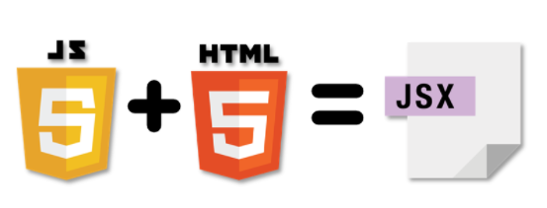

JSX is a JavaScript syntactic extension. It's a term used in React to describe how the user interface should seem. You can write HTML structures in the same file as JavaScript code by utilizing JSX.

##### Node.js

Node.js is open-source: This means that the source code for Node.js is publicly available. And it's maintained by contributors from all over the world. The Node.js contribution guide shows you how to contribute.

Node.js is cross-platform: Node.js is not dependent on any operating system software. It can work on Linux, macOS, or Windows.

Node.js is a JavaScript runtime environment: When you write JavaScript code in your text editor, that code cannot perform any task unless you execute (or run) it. And to run your code, you need a runtime environment.

## Parts of Node.js

### Parts of Node.js

##### Express.js

"Express is a fast, unopinionated minimalist web framework for Node.js" - official web site: Expressjs.com

Express.js is a web application framework for Node.js. It provides various features that make web application development fast and easy which otherwise takes more time using only Node.js.

Express.js is based on the Node.js middleware module called connect which in turn uses http module. So, any middleware which is based on connect will also work with Express.js.

##### Mongodb

MongoDB stores data in flexible, JSON-like documents, meaning fields can vary from document to document and data structure can be changed over time

The document model maps to the objects in your application code, making data easy to work with

Ad hoc queries, indexing, and real time aggregation provide powerful ways to access and analyze your data

MongoDB is a distributed database at its core, so high availability, horizontal scaling, and geographic distribution are built in and easy to use

MongoDB is free to use. Versions released prior to October 16, 2018 are published under the AGPL. All versions released after October 16, 2018, including patch fixes for prior versions, are published under the Server Side Public License (SSPL) v1.

### Need to run MongoDB

* High availability through built-in replication and failover
* Horizontal scalability with native sharding
* End-to-end security
* Native document validation and schema exploration with Compass
* Management tooling for automation, monitoring, and backup
* Fully elastic database as a service with built-in best practices

Backend :-

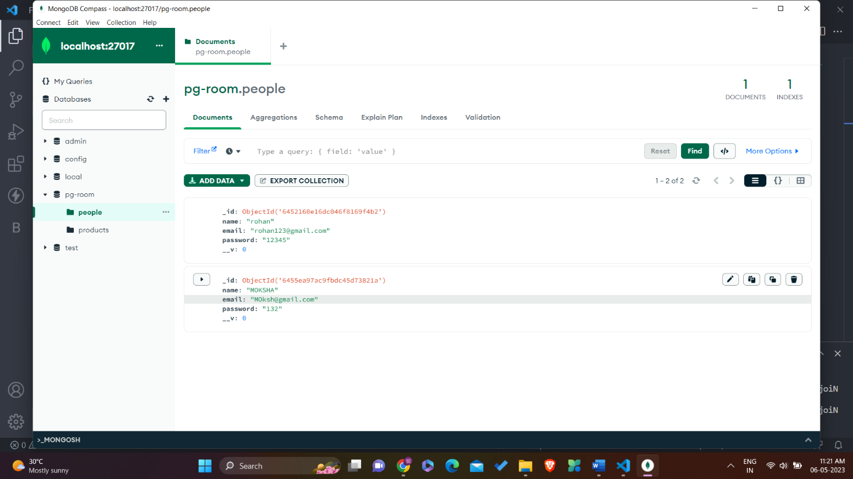

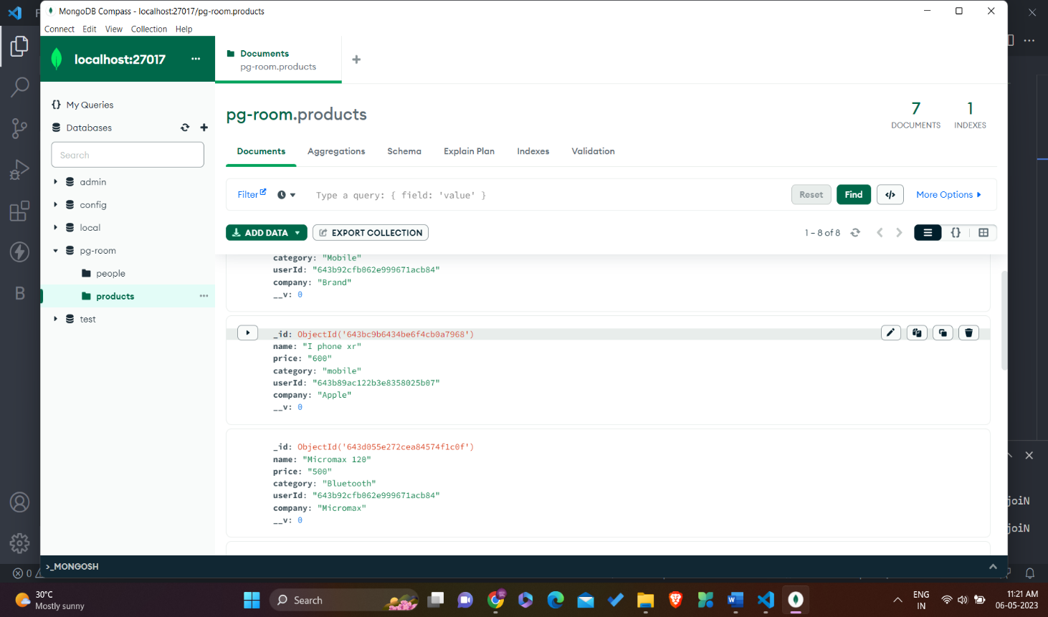

**CHAPTER 3**

# OBJECTIVES

## 1. Service or product advertising

The main purpose of a business site is to promote company’s products, services or events on the Internet. There are two main aspects to discuss. First, there are websites that don’t directly sell anything but their objective is to create “buzz” or awareness. An example would be, let’s say an event - a trance music performance taking place next month.

## 2. Importance of E-Commerce app

A project dashboard is a collection of key data, qualitative information, and visuals that summarize a portfolio of projects. It takes what would otherwise be a mass of scattered information related to all the moving parts of projects—budgets, statuses, tasks, owners, etc.—condenses it down to the most important pieces, and puts it in one convenient location. Project dashboards serve as a quick reference point for project managers, making it easy for them to keep a close eye on tasks that may be falling behind or projects that are underperforming so they can take corrective action. A screenshot of a login page

**Purpose of this Figure:**

In this Figure shows the homepage of website, here the starting page of the store, this will appear in chrome browser by clicking npm start on the terminal of VS Code.

**Purpose of this Figure:**

In this Figure shows the homepage of website of website, here the starting page of the store it shows the products which are on our website, this will appear in chrome browser by clicking npm start on the terminal of VS Code.

### 3. Providing product support and customer service

Due to its wold-wide nature, the Internet is a flexible structure allowing users to choose from thousands of similar products they are just one click away. What actually makes the difference between similar online businesses are the price and the customer support they provide.

### 4. Establishing brand awareness and identity

Establishing brand awareness or company identity is an ongoing process with the purpose of branding products with memorable names, eye-catching logos and maybe a slogan. In order to establish brand identity, your website must address these elements in a unitary manner

**CHAPTER 4**

# PLANNING/METHODOLOGY

**4.1 Methodology**

The approach used in this project is top down approach.A **top-down** approach (also known as stepwisedesign and in some cases used as a synonym of decomposition) is essentially the breaking down of a system to gain insight into its compositional sub-systems in a reverse engineering fashion. In a top-down approach an overview of the system is formulated, specifying, but not detailing, any first-level subsystems. Each subsystem is then refined in yet greater detail, sometimes in many additional subsystem levels, until the entire specification is reduced to base elements. A top-down model is often specified with the assistance of "black boxes", which makes it easier to manipulate. However, black boxes may fail to clarify elementary mechanisms or be detailed enough to realistically validate the model. Top down approach starts with the big picture. It breaks down from there into smaller segments.

**4.2 Planning**

There are two users in this project:

4.2.1 User ( with limited access )

4.2.2 Admin ( with full access )

**Functions that the user can perform:**

|  |  |
| --- | --- |
|  | Register |
|  | Login |
|  | Add/ Delete Products |
|  | Update Products |

**Purpose of this Figure:**

In this Figure shows the homepage of website where we sign up, here the starting page of the store it shows the products which are on our website, this will appear in chrome browser by clicking npm start on the terminal of VS Code.

4.3 **DATA FLOW DIAGRAM:-** The DFD two purposes

1. To provide and indicate how data are transform as they move from the system.
2. To depict the functions that transforms that data flow.

ADMINISTR

ATOR

Data

Input

Stage

Data

Storage

Data

Out

Put

Stage

Data

Out

Put

Stage

User

Data

Out

Put

Stage

Reports

User

UI

Screens

Administrator

Shopping

Cart

**Future Scope**

We can give more advance software for E-dashboard management system including more facilities.We will host the platform in online servers to make it accessible worldwide.Integrate multiple load balancer to distribute the loads of the system.Create the master and slave database structure to reduce the overload the database queries.

**Conclusion**

It has been a great pleasure for me to work on this exciting and challenging project. This project proved good for me as it provided practical knowledge of not only programming in java script and mongodb web based application. It also provides knowledge about the latest technology used in developing web enabled application and client server technology that will be great demand in future. This will provide better opportunities and guidance in future in developing projects independent

# CHAPTER 6

**SYSTEM REQUIREMENT & SPECIFICATION**

To be used efficiently, all computer software needs certain hardware components or other software resources to be present on a computer. These prerequisites are known as (computer) system requirements and are often used as a guideline as opposed to an absolute rule. Most software defines two sets of system requirements: minimum and recommended. Software requirements specification establishes the basis for an agreement between customers and contractors or suppliers on how the software product should

function.

**6.1 HARDWARE REQUIREMENTS**

* Premium200 MHz of processor
* 4 GB RAM or higher
* 512 GB Hard drive or higher

**6.2 SOFTWARE REQUIREMENTS**

**Platform:** Windows

**Operating System:** Windows 10 or any other

**Front-End tool:** HTML

**Back-End tool:** Mongodb

**Scripting tool:** Java Script , Css , Html, Express, React JS, Node JS

# REFERENCES

1. https://www.Excellence technology/

1. [https://www.google.com](https://www.google.com/)

1. [https://www.wikipedia.com](https://www.wikipedia.com/)